Bryan Guner

11/10/14

Ohms Law Lab

7. The purpose of resistor 1 is to see how current, voltage and resistance are affected by a second resistor in series.

8. (4.4-4.394)/4.394=.0013\*100=.13%

(6.6-6.629)/6.629=.0043=.43%

9-10. 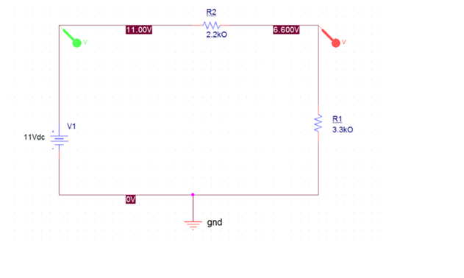

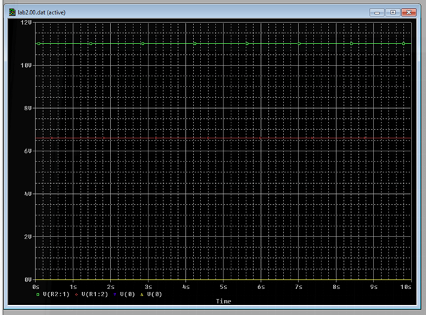

11. All of the expected, experimental and simulated values support that in a series circuit resistance and voltage are found by taking their respective sums across all the resistors, while current is constant throughout the circuit.

12. see other attached file.